Task Analysis Grid Task: 11Chem Atomic Structure Topic Test
Question | Remembering | Understanding | Applying | Analysing | Evaluating | Creating
MC1 | X
MC2 |  |  |  | X
MC3 | X
MC4 |  | X
MC5 |  |  | X
MC6 |  |  | X
MC7 |  |  |  | X
MC8 |  | X
MC9 |  |  |  | X
MC10 |  |  |  | X
MC11 |  |  |  | X
MC12 |  | X
MC13 |  | X
MC14 | X
MC15 |  | X
SA1 |  | X | X
SA2 |  | X
SA3 |  | X | X | X
SA4 | X |  |  |  | X
ER | X | X |  |  | X
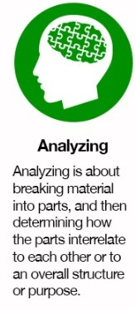
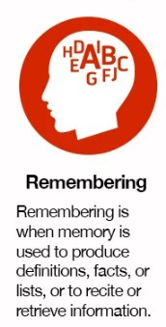
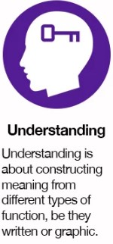
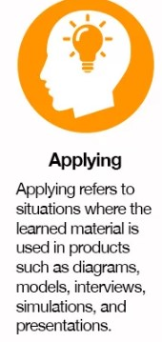
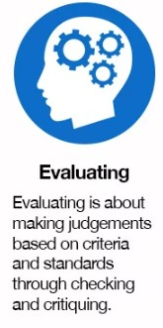
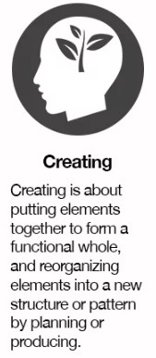

Task Analysis Grid Task:
Question | Remembering | Understanding | Applying | Analysing | Evaluating | Creating







Recollection:  Recalling items of information | Recall, identify, recognize, acquire, distinguish, state, define, name, list, label, reproduce, order, indicate,  record, relate, repeat, select, tell, describe, match, locate, report, choose, cite, define, outline, complete,  draw, find, give, isolate, pick, put, show
Comprehension / Interpretation:  Constructing meaning from information | Translate, extrapolate, convert, interpret, abstract, transform, select, indicate, illustrate, represent,  formulate, explain (who/what/when/where/that/how), classify, describe, discuss, express, identify, locate,  paraphrase, recognize, report, restate, review, summarize, find, relate, define, clarify, diagram, outline,  compare, contrast, derive, arrange, estimate, extend, generalize, give examples, ask, distinguish
Application:  Using information in new situations | Apply, sequence, carry out, solve, prepare, operate, generalize, plan, repair, explain, predict, instruct, compute, use, perform, implement, employ, solve, construct, demonstrate, give examples, illustrate, interpret, investigate, practice, measure, operate, adjust, show, report, paint, draw, collect, dramatize, classify, order, change, write, manipulate, modify, organize, produce, schedule, translate, complete, examine, advocate, persuade, resolve
Analysis:  Distilling and/or organising information into its components; solving problems  Higher order thinking skills | Analyse, estimate, detect, classify, discover, discriminate, explore, distinguish, catalogue, investigate, break down, order, determine, differentiate, dissect, examine, interpret, calculate, categorize, debate, diagram, experiment, question, solve, test, dissect, deconstruct, focus, find coherence, survey, compare, contrast, classify, investigate, outline, separate, structure, categorize, determine evidence/premises and conclusions, appraise, criticize, debate, illustrate, infer, inspect, inventory, select, deduce, induce, argue, balance, moderate, identify, explain (how/why), challenge, question
Evaluation:  Using standards, criteria, theories, or processes to judge value | Evaluate, argue, verify, assess, test, judge, rank, measure, appraise, select, check, justify, determine,  support, defend, criticize, critique, weigh, assess, choose, compare, contrast, decide, estimate, grade, rate,  revise, score, coordinate, select, choose, debate, deduce, induce, recommend, monitor, compare,  contrast, conclude, discriminate, explain (why), interpret, relate, summarize, challenge, question,  advocate, persuade
Synthesis / Creation:  Relating items of information to each other, integrating them, and generating something new | Write, plan, integrate, formulate, propose, specify, produce, organize, theorize, design, build, systematize,  combine, summarize, restate, discuss, derive, relate, generalize, conclude, produce, arrange, assemble,  collect, compose, construct, create, perform, prepare, propose, strategize, compare, contrast,  hypothesize, invent, discover, present, write, deduce, induce, bring together, pretend, predict, strategize,  modify, improve, set up, adapt, solve, categorize, devise, explain (why), generate, manage, rearrange,  reconstruct, relate, reorganize, revise, argue, extend, project, advocate, persuade, resolve

Adapted from: Course Design for Constructive Alignment (Winter 2012) Michael K. Potter and Erika Kustra Centre for Teaching and Learning, University of Windsor

